Introduction to Simulink Support for Target Hardware

[Introduction to Simulink Support for Target Hardware - Video - MATLAB & Simulink (mathworks.cn)](https://ww2.mathworks.cn/videos/introduction-to-simulink-support-for-target-hardware-68955.html)

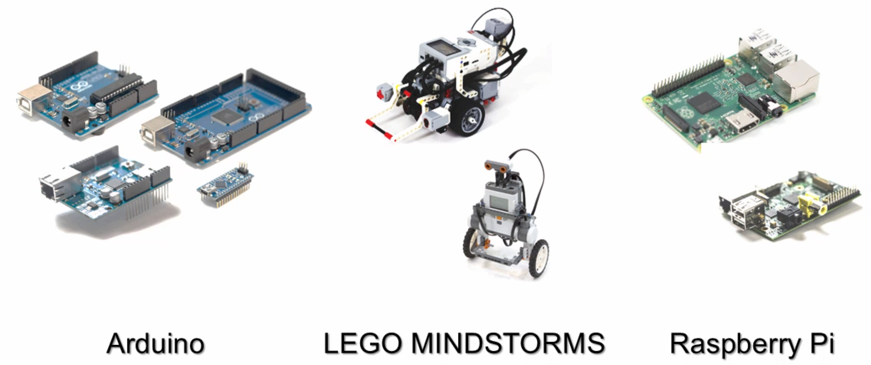

* 安装**MATLAB Support Package for Raspberry Pi Hardware**和**Simulink Support Package for Raspberry Pi Hardware**

# Introduction to Simulink: Quadcopter Simulation and Control

[Introduction to Simulink: Quadcopter Simulation and Control - Video - MATLAB & Simulink (mathworks.cn)](https://ww2.mathworks.cn/videos/introduction-to-simulink-quadcopter-simulation-and-control-100476.html)

# Quadcopter Simulation and Control Made Easy

[Quadcopter Simulation and Control Made Easy - Video - MATLAB & Simulink (mathworks.cn)](https://ww2.mathworks.cn/videos/quadcopter-simulation-and-control-made-easy-93365.html)